**Technical Title**

**One2Many Speech Translator**

Table of Contents

**Technical Abstract** 3

**Technical System Architecture** 4

**Technical Workflow** 5

**For Host** 6

**For Clients** 6

# **Technical Abstract**

Even with the evolution of technologies, the communication between humans still met many difficulties due to the fact that people speak different languages. This phenomenon has greatly affected the fields where communication and language understanding are important in transferring ideas and thoughts. Conventional translation systems such as Google Translate offers a great service to these domains, but they only able to receives input speech via a single device and display the result on the same device.

In this project, a mobile application – One2Many Speech Translator is developed as an enhancement for conventional translation application by receiving input from a single smartphone, and outputting the results of the translation on multiple smartphones that have the same application installed. One2Many Speech Translator is useful for professions that depend heavily on communication. For instance, during a speaks, the speaker can use this mobile application and speaks in their language, and the speech will be passed to each individual audience via smartphone, and translating those speech into the selected language of the particular audience.

In a nutshell, One2Many Speech Translator provides a more effective and efficient manner in providing translated language across multiple smart devices and most importantly – bridging the gap between languages understanding

# **Technical System Architecture**

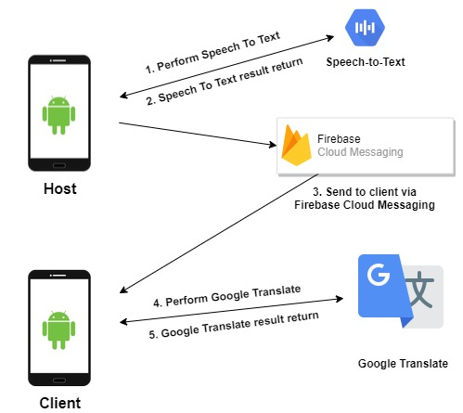

# **Technical Workflow**

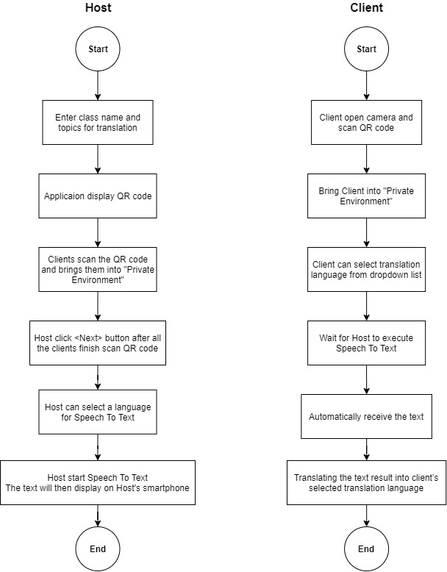

## **For Host**

1. Install the One2Many Speech Translator from Google Play Store
2. Register Host account with Email Address, password, and choose Host role
3. Head over to your email address and verify your account
4. Login by using email address or Google sign-in
5. Enter a class and a topic name
6. Click <Generate QR Code> button and allow other client smartphones to scan
7. After all client smartphone scanned the QR Code, click <Next> button.
8. This will bring Host enter a private “environment”, which the translation and only happens within that environment
9. Host can select a language from the dropdown list before executing Speech to Text
10. The application is now executing Speech to Text into selected language
11. Speech to Text result will be displayed and broadcast the result to multiple clients

## **For Clients**

1. Install the One2Many Speech Translator from Google Play Store
2. Register Client account with Email Address, password, and choose Client role
3. Head over to your email address and verify your account
4. Login by using email address or Google sign-in
5. Allow permission to take use camera on the mobile application
6. Click <Open Camera> button
7. Scan the QR code which displayed on the One2Many Host mobile application
8. This will bring clients enter a private “environment”, which the translation only happens within that environment
9. Client can choose translation language from the dropdown list
10. Wait for the Host to execute Speech to Text
11. The client phone will automatically receive the text and translating the text result into client’s selected translation language